**Software Requirements Specification**

**for**

NoCom

**Version 1.0 approved**

**Prepared by Kempton Maillett, Obed Appiah, Ben Caras, Anthony Weaver, Bryce Roy**

**HubDivers**

**10 October 2024**

**Table of Contents**

**Table of Contents ii**

**Revision History ii**

**1. Introduction 1**

1.1 Purpose 1

1.2 Document Conventions 1

1.3 Intended Audience and Reading Suggestions 1

1.4 Product Scope 1

1.5 References 1

**2. Overall Description 2**

2.1 Product Perspective 2

2.2 Product Functions 2

2.3 User Classes and Characteristics 2

2.4 Operating Environment 2

2.5 Design and Implementation Constraints 2

2.6 User Documentation 2

2.7 Assumptions and Dependencies 3

**3. External Interface Requirements 3**

3.1 User Interfaces 3

3.2 Hardware Interfaces 3

3.3 Software Interfaces 3

3.4 Communications Interfaces 3

**4. System Features 4**

4.1 System Feature 1 4

4.2 System Feature 2 (and so on) 4

**5. Other Nonfunctional Requirements 4**

5.1 Performance Requirements 4

5.2 Safety Requirements 5

5.3 Security Requirements 5

5.4 Software Quality Attributes 5

5.5 Business Rules 5

**6. Other Requirements 5**

**Appendix A: Glossary 5**

**Appendix B: Analysis Models 5**

**Appendix C: To Be Determined List 6**

**Revision History**

| **Name** | **Date** | **Reason For Changes** | **Version** |
| --- | --- | --- | --- |
|  |  |  |  |
|  |  |  |  |

# **Introduction**

## **Purpose**

*NoCom is a web-based application designed to help beginner programmers improve their ability to read and understand code. The primary goal is to allow users to input code snippets and receive line-by-line explanations, breaking down syntax, logic and structure. This document outlines the requirements needed to build the NoCom platform.*

## **Document Conventions**

*This document was created based on the Institute of Electrical and Electronic Engineers (IEEE) template for System Requirement Specification (SRS) Documents.*

*The following conventions were used as follows:*

| **Convention** | **Description** |
| --- | --- |
| *NoCom* | *Name of the application: NoCom* |
| *Artificial Intelligence (AI)* | *Generative AI used for code explanations* |

## **Intended Audience and Reading Suggestions**

This document is intended to be read and maintained by the project manager, designer, and developers. It provides details on product scope, system features, non functional requirements, and other relevant aspects. It is recommended to start with the overview sections and proceed to system features for detailed functionality followed by non- functional requirements.

*<Describe the different types of reader that the document is intended for, such as developers, project managers, marketing staff, users, testers, and documentation writers. Describe what the rest of this SRS contains and how it is organized. Suggest a sequence for reading the document, beginning with the overview sections and proceeding through the sections that are most pertinent to each reader type.>*

## **Product Scope**

*The software used will be a React based web application. Its primary purpose is to help programmers of all levels understand and write code. This application will provide feedback to users based on their code that they have written as well as providing applicable resources to users on their code. This application will allow for users to learn and understand code in a more efficient and effective manner.*

## **References**

1. *NoCom GitHub link:* [*https://github.com/COS420-Fall24/TeamH*](https://github.com/COS420-Fall24/TeamH)
2. *IEEE Standard for SRS, IEEE Std 830-1998*

# **Overall Description**

## **Product Perspective**

*This product will build off of existing generative AI technologies to provide explanations and recommend scenarios from our library of pre-built coding lessons.*

## **Product Functions**

*The major functions of this product are:*

* *The system must allow users to create an account using an email and password*
* *The system shall allow the user to enter a snippet of code*
* *The system shall allow the user to copy in documents of code that the user has already created*
* *The system shall read and provide an understanding of what the code does in a basic readable format*
* *The system shall allow the user to give a more in depth degree of feedback if specified*

## **User Classes and Characteristics**

*The user classes include system admins, developers and users. Users will be the most frequent actors on the application, therefore this application and its requirements are built around these users. These users will be able to access all system features.*

*System admins and developers will have elevated permissions and will oversee the design, specification, implementation, and maintenance of the application. These classes will have higher security and privilege levels which will give them the ability to help fix problems as well as access and control systems within the application.*

## **Operating Environment**

*NoCom is designed to work as a web and mobile application. It shall function properly on any operating system that has an up to date version of chrome, microsoft edge, as well as on up to date mac and android operating systems.*

## **Design and Implementation Constraints**

*NoCom has several design implementations that must be considered during development:*

1. *Programming Language: NoCom will be developed using JavaScript (JS) with Hypertext Markup Language (HTML) and Cascading Style Sheets (CSS) for user interface design. These technologies are chosen for their flexibility and support for modern web applications*
2. *AI service: The app relies on cloud-based AI services for code analysis and explanation generation. The choice of AI service is constrained to those that support programming language detection and text generation such as OpenAI’s Application Programming Interface (API).*
3. *Database: NoCom will use a Not only Structured Query Language (NoSQL) database to store data. Database choice is constrained by the need for scalability and flexibility in handling unstructured data*
4. *Cross Platform Compatibility: The system must support all major web browsers including Chrome, Firefox, Safari and Edge on both mobile and desktop devices.*
5. *User Data Privacy: The system must comply with data privacy regulations like General Data Protection Regulation (GDPR). This requires secure storage and handling of users to delete their data*
6. *Performance Constraints: The app is designed to provide real time feedback which requires efficient handling of code input and analysis process. The constraint is limits choice of libraries and frameworks to those that support quick processing times*

## **User Documentation**

*This product will come with a collection of pre-built coding lessons which the generative AI will recommend to the user based on what they are learning and the problems they are running into.*

## **Assumptions and Dependencies**

*This project will rely heavily on a third-party generative AI technology, likely OpenAI’s ChatGPT model. It is assumed that we will be able to interface with their API for free.*

# **External Interface Requirements**

## **User Interfaces**

*This application will welcome the user with a home screen that allows the user to revisit past conversations or start a new one by inputting a code snippet. Users can choose to sort conversation by recency or by topics. The generative AI will create a title for each conversation based on the topics being discussed. It will look much like the chatgpt site, but with an added section that tracks the resources which have been recommended to the user, with links to their conversations of origin.*

## **Hardware Interfaces**

*This product will be a web-based application and will be accessible by any modern web browser.*

## **Software Interfaces**

## ***Data Flow***

*1. Input Data (Coming into NoCom):*

*User Input: Code snippets or questions about specific programming concepts.*

*2. Outgoing Data:*

*AI Requests: JavaScript Object Notation (JSON)-based requests sent to ChatGPT’s API containing the user input.*

*Purpose: To generate an appropriate code explanation, correction, or feedback.*

*3. Incoming Data (From ChatGPT):*

*AI Responses: JSON responses containing explanations, code suggestions, or debugging information.*

*4. Outgoing Data to User:*

*Processed Feedback: NoCom delivers AI responses in a user-friendly format (like code blocks or rich text explanations) back to the user interface.*

*React (version 18.0) will be used for the frontend, enabling users to input code and see results dynamically.*

## **Communications Interfaces**

*Users will interact with NoCom through a modern web browser interface. The system will use standard web technologies such as HTML5, CSS3, and JS (React). The data exchanged between the browser and the backend server will be structured as JSON. Hypertext Transfer Protocol Secure (HTTPS) will be used to handle requests between the browser and the server. NoCom will send API calls to ChatGPT’s generative AI endpoint via HTTPS. Each request will include the user’s input as a JSON object, and the response will also be returned as JSON.*

# **System Features**

## Account Creation/Deletion

4.1.1 Description and Priority

Users will be able to create an account with an email and a password, high priority.

4.1.2 Stimulus/Response Sequences

4.1.3 Functional Requirements

4.1.4 Signing in and out

4.1.5 Account creation/deletion

*Functional Requirement 1 (F-REQ-1): The system shall allow users to create an account using an email and password*

*F-REQ-2: The system shall allow the user to sign in and sign out of their account at any point*

*F-REQ-3: The system shall allow the user to delete their account at any point*

*F-REQ-4: The system shall prompt the user to enter a email and password upon sign in*

*F-REQ-5: The system shall prompt the user with an error message if the email or password doesn’t match specified requirements*

## Entering Code

4.2.1 Description and Priority

Users will be allowed to enter snippets of code or import documents that they have previously created, high priority.

4.2.2 Stimulus/Response Sequences

4.2.3 Functional Requirements

*F-REQ-6: The system shall allow the user to enter a snippet of code*

*F-REQ-7: The system shall allow the user to copy in documents of code that the user has already created*

*F-REQ-8: The system shall read the code that was copied from the user*

*F-REQ-9: The system shall place the code into ChatGPT API*

*F-REQ-10: The system shall request translation of the code entered into ChatGPT API*

*F-REQ-11: The system shall pull the information given from the result that ChatGPT API sent*

*F-REQ-12: The system shall put the information given from ChatGPT API into the conversation between the user and the system*

*F-REQ-13: The system shall allow the user to enter another request if necessary*

## Code Feedback

4.3.1 Description and Priority

The system shall provide feedback to the user based on the code that they have entered using generative AI. The user will be able to determine the degree of feedback they wish to receive on the code, they will be able to choose if they want a basic explanation or an in depth explanation on the code they entered.

4.3.2 Stimulus/Response Sequences

4.3.3 Functional Requirements

*F-REQ-14: The system shall read and provide an understanding of what the code does in a basic readable format*

*F-REQ-15: The system shall allow the user to specify that they want a more in depth degree of feedback*

# **Other Nonfunctional Requirements**

## **Performance Requirements**

*Nonfunctional Requirement 1(NF-REQ-1): The system shall ensure a 99.9% uptime for constant availability.*

*NF-REQ-2: The system shall support at least 1000 concurrent users without a decrease in performance*

*NF-REQ-3: The system shall process and provide explanations for code snippets of up to 500 lines within 5 seconds*

## **Safety Requirements**

*NF-REQ-4: The system shall prevent any code execution to avoid harmful code input*

## **Security Requirements**

*NF-REQ-5: The system shall use HTTPS for secure communication.*

*NF-REQ-6: The system shall have high usability, provide clear instructions and feedback for all user actions*

*NF-REQ-7:Users will provide their email and a password to create an account:*

*NF-REQ-8: Users information will not be shared with any third party companies or organizations*

*While NoCom will not be used to transmit any sensitive data, all transmissions between the user’s browser, NoCom’s server, and the ChatGPT API will be encrypted using Secure Socket Layer (SSL)/Transport Layer Security (TLS) to ensure that data in transit is secure.*

## **Software Quality Attributes**

*NF-REQ-9: The system shall be responsive, supporting use on mobile and desktop devices.*

*NF-REQ-10: The system shall be available to users 97% of the time*

## **Business Rules**

*NF-REQ-11: The system shall allow Administrators to access, and edit file repositories.*

*NF-REQ-12: The system shall allow Administrators to disable or delete User accounts only when necessary.*

*NF-REQ-13: The system shall allow Administrators to view user account information besides Personally Identifiable Information (PII)*

*NF-REQ-14: The system shall allow Administrators to view user account history*

*NF-REQ-15: The system shall allow Users to access personal account information.*

*NF-REQ-16: The system shall allow Users to access personal account history.*

# **Other Requirements**

*Potentially will edit later in case anything unexpected*

**Appendix A: Glossary**

*NoCom: Name of application*

*AI: Artificial Intelligence*

*IEEE: Institute of Electrical and Electronic Engineers*

*SRS: Software Requirements Specification*

*HTML: Hypertext Markup Language*

*CSS: Cascading Style Sheets*

*API: Application Programming Interface*

*NoSQL: Not only Structured Query Language*

*GDPR: General Data Protection Regulation*

*JSON: JavaScript Object Notation*

*JS: JavaScript*

*HTTPS: Hypertext Transfer Protocol Secure*

*NF-REQ-#: Nonfunctional Requirement #*

*F-REQ-#: Functional Requirement #*

*SSL: Secure Socket Layer*

*TLS: Transport Layer Security*

*PII: Personally Identifiable Information*

**Appendix B: Analysis Models**

[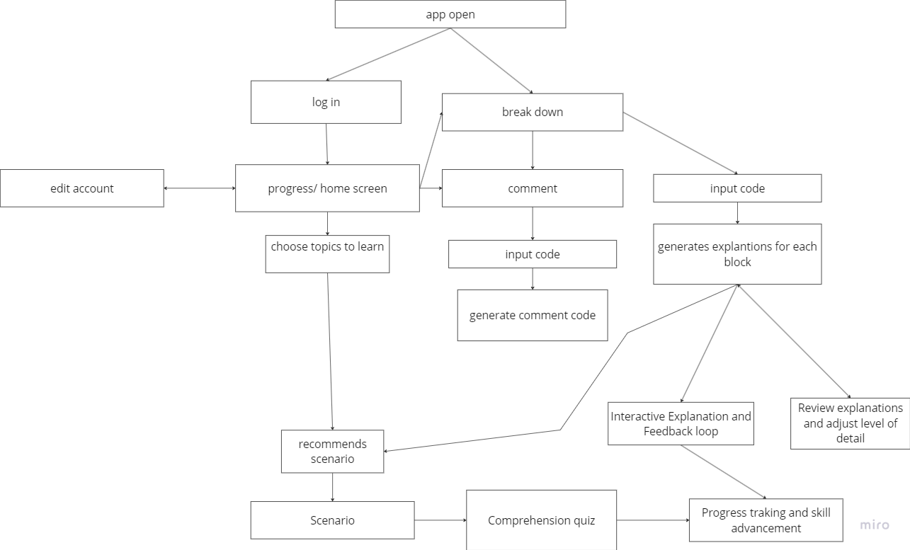](https://miro.com/app/board/uXjVLUWJ178=/?userEmail=bryce.roy@maine.edu&track=true&utm_source=notification&utm_medium=email&utm_campaign=add-to-team-and-board&utm_content=boardName)

*Link is attached to image 👍*[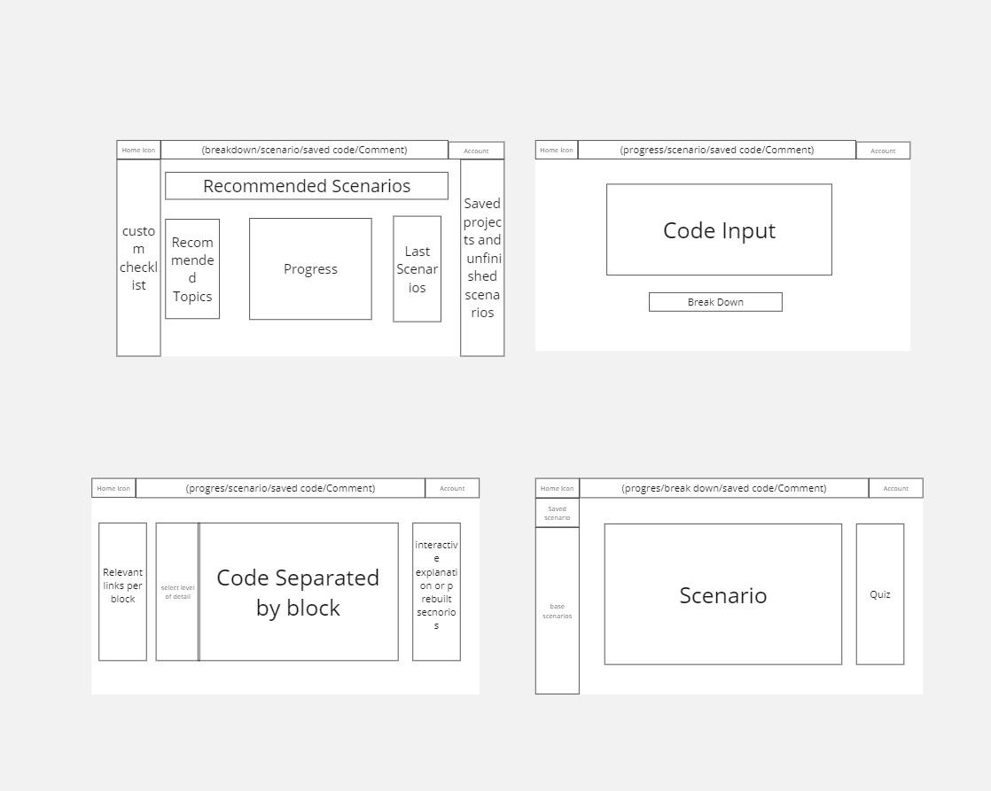](https://miro.com/app/board/uXjVLUWJ178=/?userEmail=bryce.roy@maine.edu&track=true&utm_source=notification&utm_medium=email&utm_campaign=add-to-team-and-board&utm_content=boardName)

**Appendix C: To Be Determined List**